Cover Page
Project Title: Python Quiz Game
Student Name: Priyanshi Varshney
Course : Introduction to problem solving ( Python essentials)
Registration number : 26BAI10184
University : VIT Bhopal
Submitted To: Mr. Ashfaq Ahmad Najar
Academic Year : 2026-2027

Introduction

Python Quest is a simple quiz game made in Python. It has 5 units. In each unit, 3 questions are asked. The player gets points for correct answers. At the end, total score and percentage are shown.

Problem Statement
In today's time, students find coding subjects like Python boring and difficult to understand just by reading theory. They learn syntax but are not able to apply it in real programs. So the problem is:
"How to make Python learning more interactive and interesting for students ? "To solve this problem, I have made a Python Quiz Game named "Python Quest".
This game asks simple questions from 5 units of Python - Basics, Conditions, Loops, Functions, and Lists. The player gets points for correct answers and at the end, total score and percentage is shown. This helps students to practice and revise Python concepts in a fun way.
Le bhai *Functional Requirements* 👇

Report me seedha copy kar de

---

FUNCTIONAL REQUIREMENTS

1. User Input: The system should take the player's name at the start of the game.
2. Question Display: The system should display 3 questions from each of the 5 units one by one.
3. Answer Checking: The system should check the answer entered by the user and tell if it is correct or wrong.
4. Second Attempt: If the first answer is wrong, the system should give one more chance to answer.
5. Scoring System: The system should give 50 points for correct answer on first attempt and 25 points on second attempt.
6. Score Tracking: The system should keep track of the total score during all 5 rounds.
7. Final Result: At the end of the game, the system should display the final score out of 750.
8. Percentage Calculation: The system should calculate and display the percentage of marks obtained.

Non-functional Requirements

User Friendly: The game should be easy to understand and use. Even a beginner can play it.
Reliability: The game should run without crashing and give correct score every time.
Performance: The game should respond quickly to user input without any delay.
Portability: The game is made in Python so it can run on any computer where Python is installed.
Maintainability: The code is divided into different files like main.py and unit1.py to unit5.py so it is easy to update and add new questions.
Simplicity: The interface is text-based and simple so that it focuses on learning, not on graphics.

System Architecture
The project Python Quest is designed using Modular Programming. The whole system is divided into small parts so that it is easy to understand and maintain.
1. Main Module: main.py
This is the starting point of the game.
- Takes player name
- Controls all 5 rounds
- Calls functions from other files
- Calculates total score and percentage
- Displays final result
2. Helper Module: helpers.py
This file contains common functions used in the game.
- show_header() - Shows round number and score
- show_progress() - Shows game progress

3. Unit Modules: unit1.py to unit5.py
Each unit file has 3 questions related to that topic.
unit1.py – Basics
unit2.py - Conditions
unit3.py – Loops
unit4.py – Functions
unit5.py – Lists
Each question is written inside a separate function.

Design Diagrams

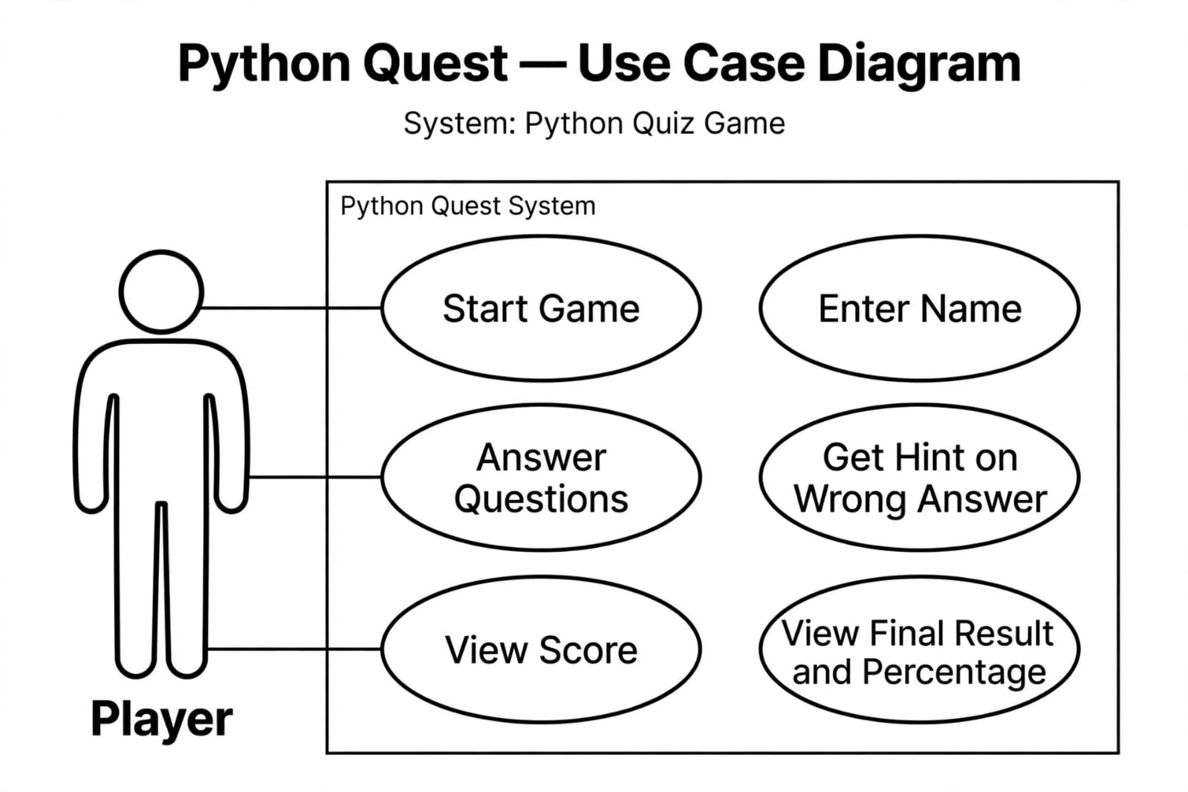

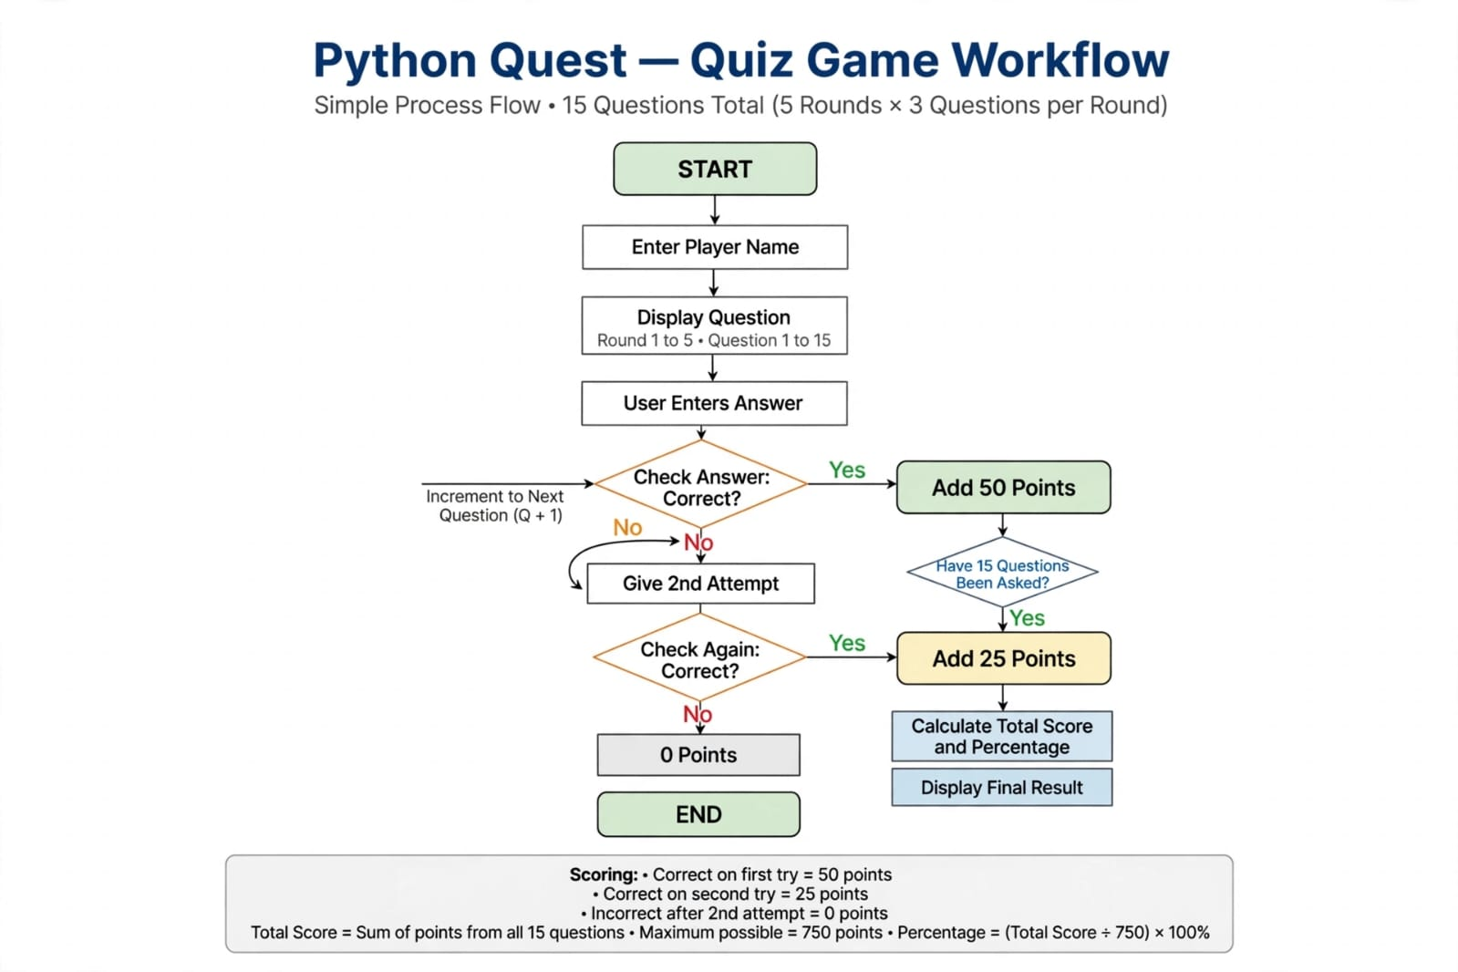

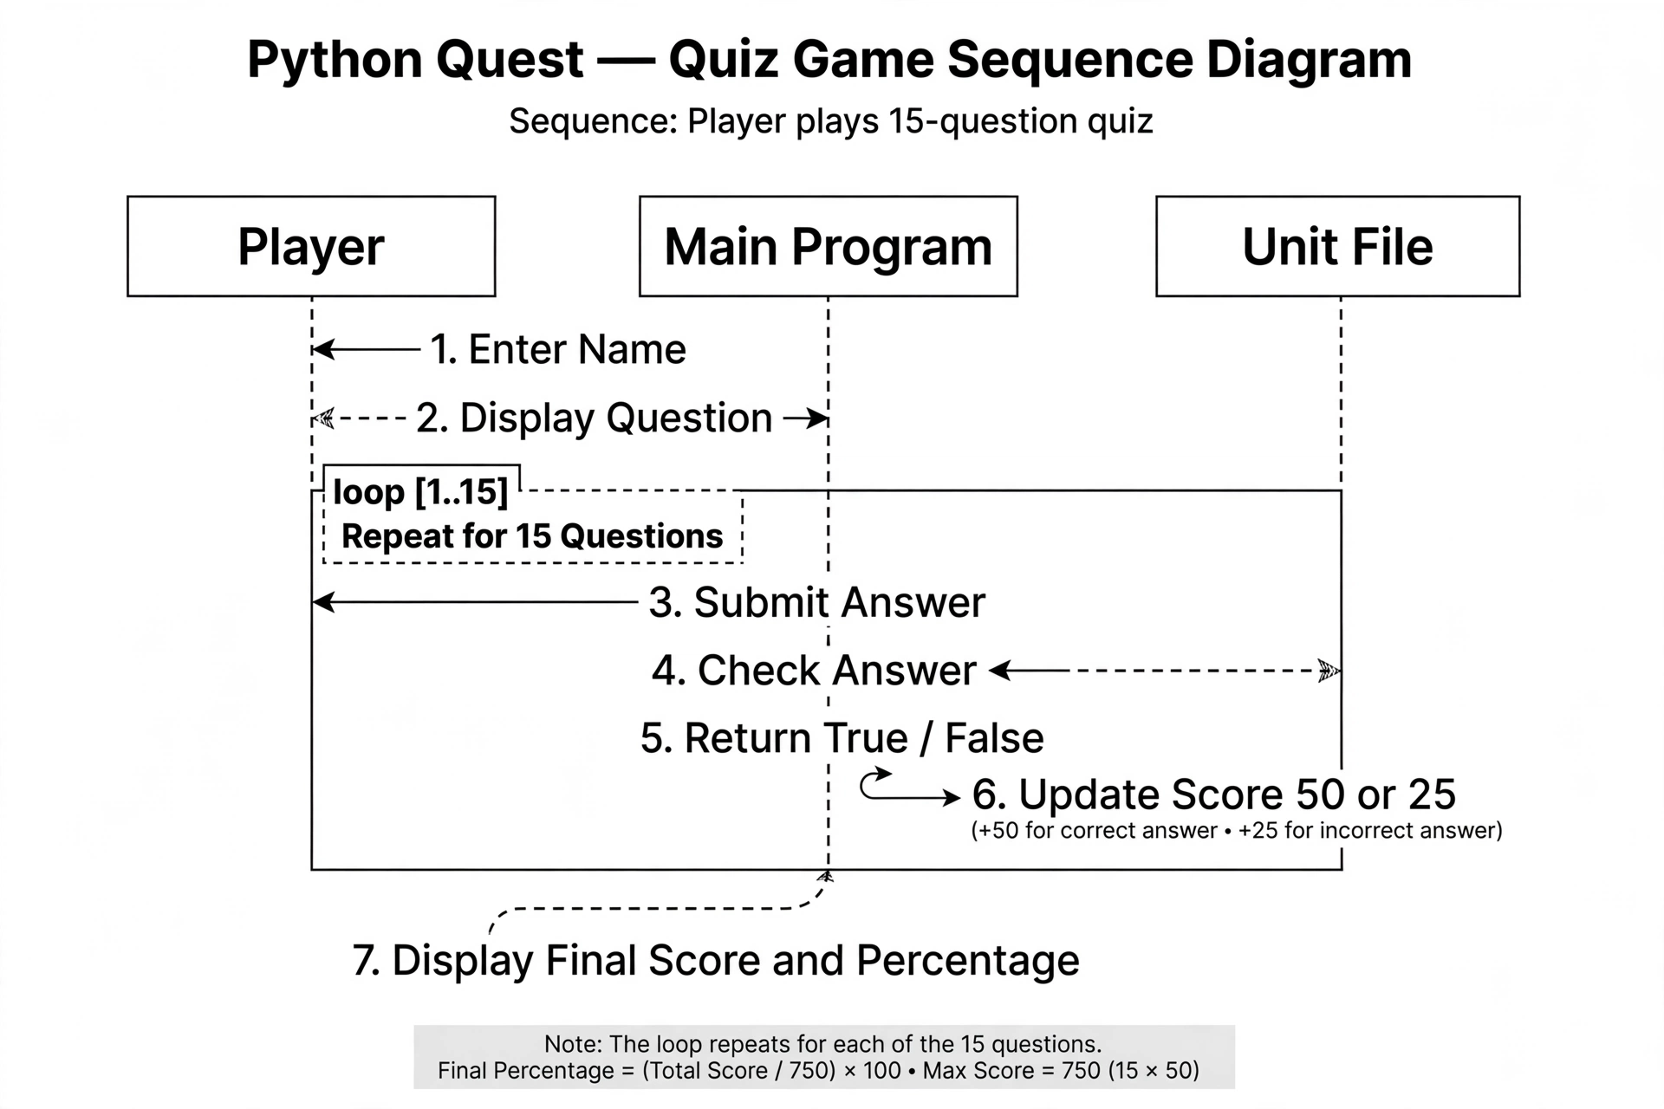

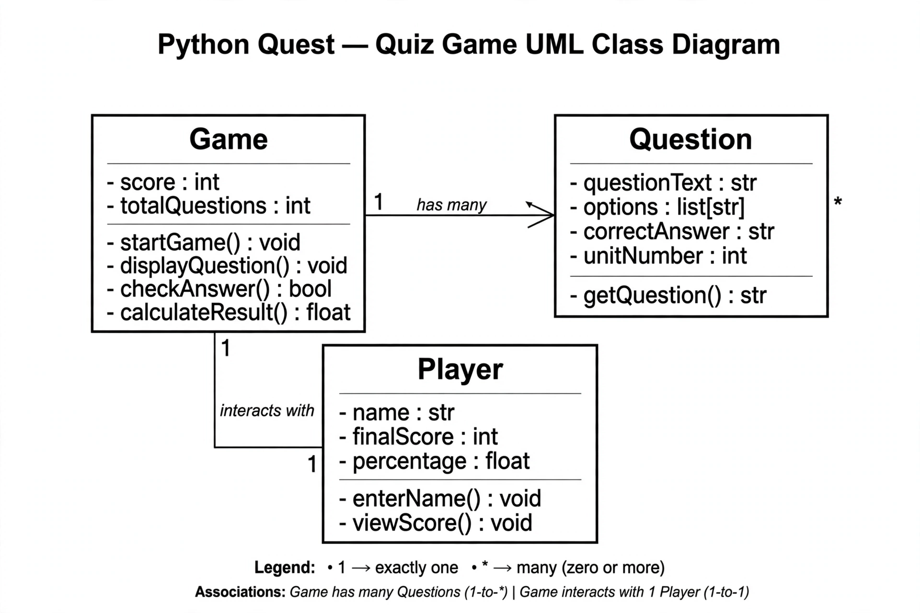

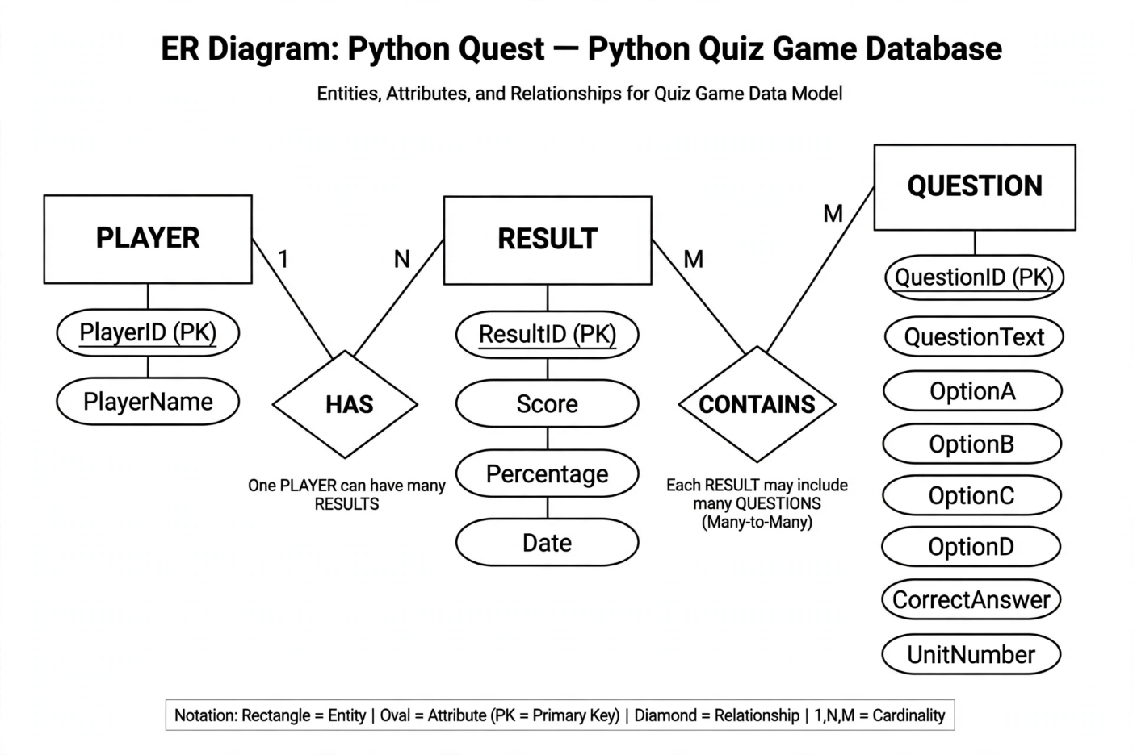
DESIGN DECISIONS AND RATIONALE
Modular File Structure
Decision:
Code is divided into main.py, helpers.py and unit1.py to unit5.py.
Rationale:
This follows the principle of modularity. It makes the code easier to understand, debug, and maintain. Adding new questions in future only requires changes in the specific unit file.
Console-Based Text Interface
Decision:
The game runs on command line/terminal instead of GUI.

Rationale:
For a school project, the main focus is on Python logic and OOP concepts. GUI would increase complexity and development time without adding learning value.
Two Attempts with Different Scoring
Decision:
1st correct attempt = 50 points, 2nd correct attempt = 25 points.
Rationale:
This decision encourages the player to think carefully. It also acts as a learning tool where the player gets a second chance and is still rewarded, but less than the first attempt.
Fixed 15 Questions from 5 Units
Decision:
3 questions from each of 5 Python topics: Basics, Conditions, Loops, Functions, Lists.
Rationale:
15 questions are sufficient to cover the syllabus and test the player without making the game too long. It also helps in balanced revision.
No External Libraries Used
Decision:
Only built-in Python functions like input(), print(), len() are used.
Rationale:
To keep the project simple and ensure it can run on any system with Python installed. This also proves that the core logic is implemented from scratch.
Score and Percentage Calculation
Decision:
Final output shows both total score out of 750 and percentage.
Rationale: Score shows absolute performance while percentage gives a relative idea. This helps students self-evaluate and compare their performance.

IMPLEMENTATION DETAILS

Programming Language
Python 3.10 was used for the entire project. Python was chosen because of its simple syntax, readability, and suitability for beginners. It also supports modular programming which helped in organizing the code.
Development Environment & Tools IDE:
VS Code Compiler/Interpreter: Python 3.x OS: Windows 10/11 No external libraries were used. Only built-in functions.
File Structure & Modules
The project is divided into 7 .py files for better management:
PythonQuest/
├── main.py # Controls game flow, takes input, calculates final score
├── helpers.py # Contains helper functions like print_header(), progress_bar()
└── src/
├── unit1.py # 3 Questions on Python Basics
├── unit2.py # 3 Questions on If-Else & Conditions
├── unit3.py # 3 Questions on Loops
├── unit4.py # 3 Questions on Functions
└── unit5.py # 3 Questions on Lists
Core Algorithms & Logic Game Loop:
A for loop runs 5 times for 5 units. Inside each unit, another loop runs 3 times for 3 questions. Total = 15 questions.
Answer Checking:
if answer.lower() == correct_answer.lower() is used for case-insensitive matching.
Scoring System:
if correct in 1st attempt: score += 50
elif correct in 2nd attempt: score += 25
else: score += 0Percentage Formula: Percentage = (Total Score / 750) * 100
Error Handling
If user enters blank name, program asks again using while loop. If user enters invalid option, it asks to enter again..strip() and .lower() are used to handle extra spaces and case issues.
Sample Output
GAME OVER!
Final Score: 725 / 750
Percentage: 96.67 %

Screenshots / Results

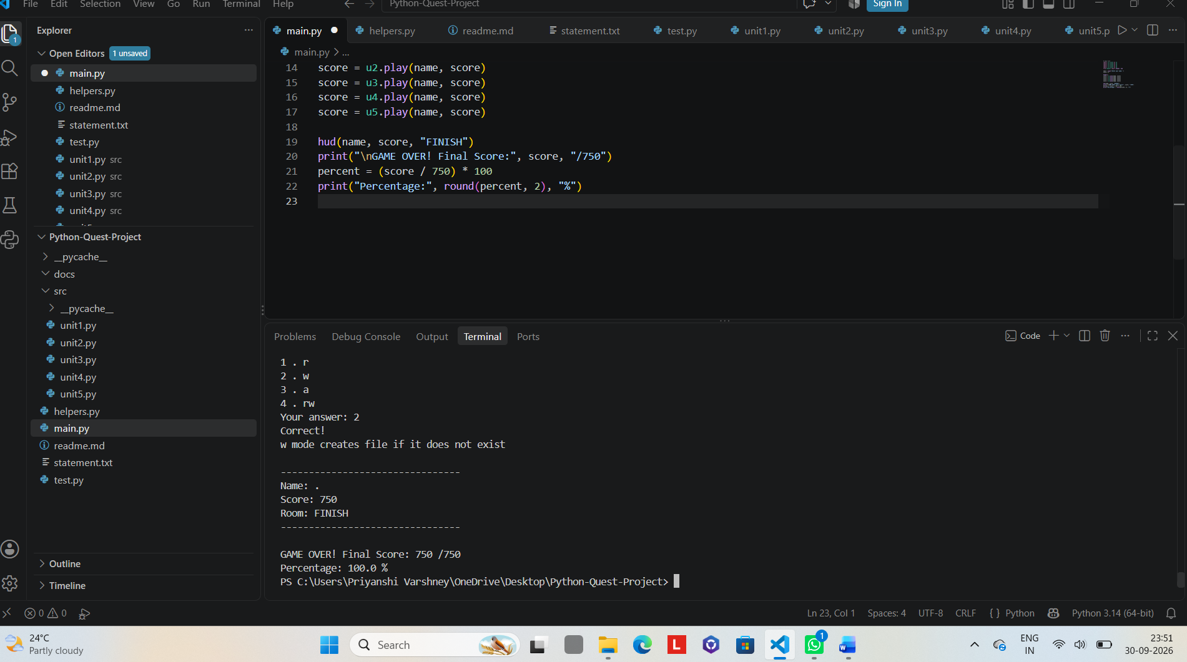

TESTING APPROACH
Testing was done to ensure that the Python Quest game works correctly and gives accurate results. Both manual and logical testing were performed.
1. Types of Testing Used
Unit Testing
Purpose: To test each unit file separately.
Method: Each unit1.py to unit5.py was run individually to check if all 3 questions were displaying correctly and answers were being checked properly.
Result: All 15 questions worked as expected.
Integration Testing
Purpose: To test if main.py is correctly calling all unit files and helpers.py.
Method: Ran the full main.py and checked if the game flows from Unit 1 to Unit 5 without errors.
Result: All modules were integrated successfully.
System Testing
Purpose: To test the whole system as a player would use it.
Method: Played the complete game 3 times with different inputs.
Result: The final score and percentage were calculated correctly.
User Acceptance Testing
Purpose: To check if the game is user-friendly.
Method: 2 friends played the game and gave feedback.
Feedback: Interface was simple, instructions were clear, scoring system was fair.
Limitations Found During Testing
- If the program closes, previous score is not saved.
- No timer for each question.
- Case sensitivity handled but spelling mistakes are not.

CHALLENGES FACED AND SOLUTIONS
While developing Python Quest, I faced some challenges. Here’s how I handled them:
- Managing 15 Questions Efficiently
Challenge: Writing all 15 questions in one file made the code very long and messy.
Solution: I divided questions into 5 separate files unit1.py to unit5.py. This made the code modular and easy to edit. Adding new questions later also became simple.
- Scoring Logic with 2 Attempts
Challenge: Keeping track of 1st and 2nd attempt for each question and assigning 50 or 25 points accordingly was confusing at first.
Solution: I used a for attempt in range(2) loop inside each question. A flag variable was used to check if the answer was correct in 1st attempt or not.
- Input Validation
Challenge: If the user enters a blank name or invalid option, the program would crash or skip the question.
Solution: I added while loops with .strip() and .lower() to validate input. If input is invalid, it asks the user again until valid input is given.
4. Calculating Final Percentage
Challenge: Initially I forgot that max score is 750, not 100. So percentage was coming wrong.
Solution: Used formula: Percentage = (TotalScore / 750) * 100 and tested it with sample scores.
- Making Output Look Clean
Challenge: Plain print() statements made the output look boring.
Solution: Created helpers.py with functions like print_header() and progress_bar() to make the interface more presentable for the report and viva.
Future Improvements / Scope
File Handling: Save player name, score, and date in a .txt or .csv file for record.
Timer: Add 30 second timer for each question.
GUI Version: Convert to Tkinter or PyGame for better graphics.
More Units: Add chapters like Dictionary, File Handling, OOP.

LEARNING AND TAKEAWAYS
Python Concepts: I learned how to use functions, loops, lists, and modular programming in a real project.
Problem Solving: Breaking a big problem into smaller modules made coding easier and less confusing
.Input Validation: I understood the importance of handling wrong inputs to make the program user-friendly.
Planning: Designing diagrams like Flowchart, Sequence and Class diagram before coding helped a lot.
Overall: This project improved my logical thinking and gave me confidence in using Python for real

FUTURE ENHANCEMENT
File Handling: Save player scores and history in a .txt or .csv file.
Timer: Add a time limit for each question to make it more challenging.
GUI Version: Convert the game to Tkinter or PyGame for better graphics.
More Topics: Add units on Dictionaries, OOP, and File Handling.
Leaderboard: Show top 5 scores for competition.
REFERENCES
Python Documentation: python.org
W3Schools Python Tutorial: w3schools.com
NCERT Class 11 & 12 Computer Science Textbook
GeeksforGeeks: For Python concepts and examples applications.

